**Importing CSV file using MySQL Workbench**

MySQL workbench provides a tool to import data into a table. It allows you to edit data before making changes.

The following are steps that you want to import data into a table:

Open table to which the data is loaded.

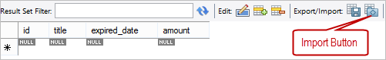

Click Import button, choose a CSV file and click Open button

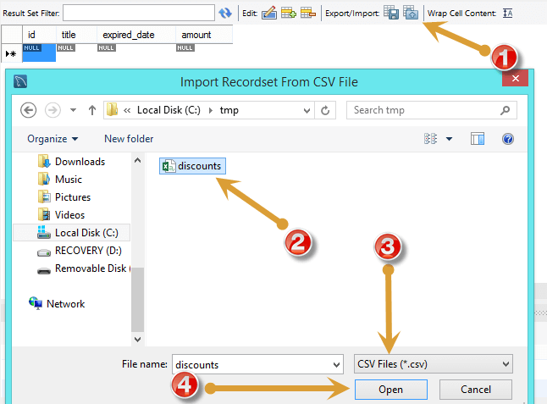

Review the data, click Apply button.

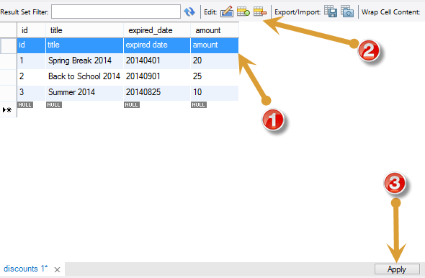

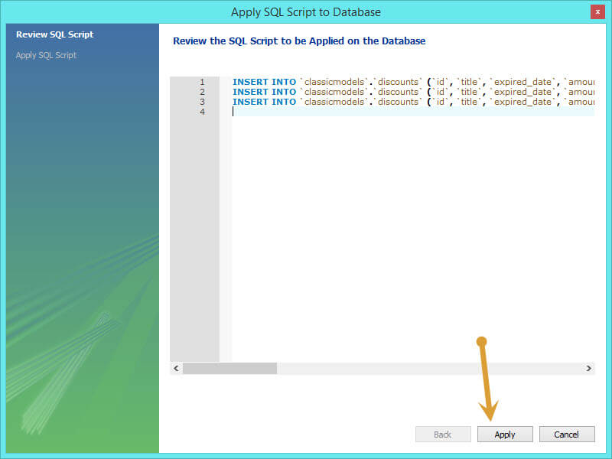

MySQL workbench will display a dialog  “Apply SQL Script to Database”, click Apply button to insert data into the table.